**Analysis of IKEA.in**

**Introduction:**

I've performed analysis of [IKEA.in](https://www.ikea.com/in/en/), utilizing a blend of powerful analytics tools such as Microsoft Clarity, alongside data from [Semrush](https://www.semrush.com/analytics/overview/?q=ikea.in&searchType=domain) and [SimilarWeb](https://pro.similarweb.com/#/digitalsuite/websiteanalysis/overview/website-performance/*/999/3m?webSource=Total&key=ikea.in). This exhaustive report aims to unearth profound insights into user behavior, website functionality, and avenues for growth. As the primary online platform for IKEA in India, IKEA.in is dedicated to providing a seamless shopping experience tailored to the diverse needs and preferences of Indian consumers.

**Website Overview:**

Stepping into IKEA.in unveils a digital showroom brimming with Scandinavian-inspired furniture and home accessories. From sleek sofas to vibrant décor, the website beckons visitors to explore products designed to elevate every corner of an Indian home.

**Key Metrics Analysis:**

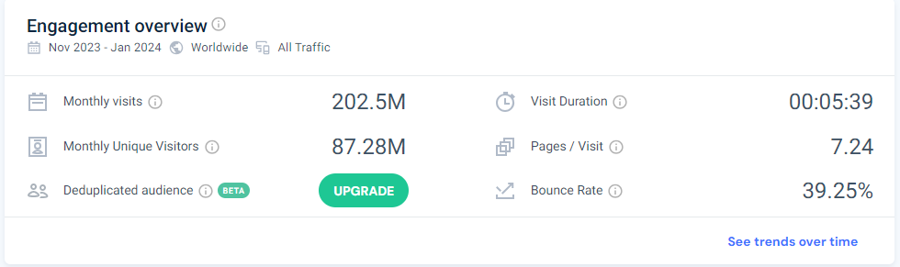

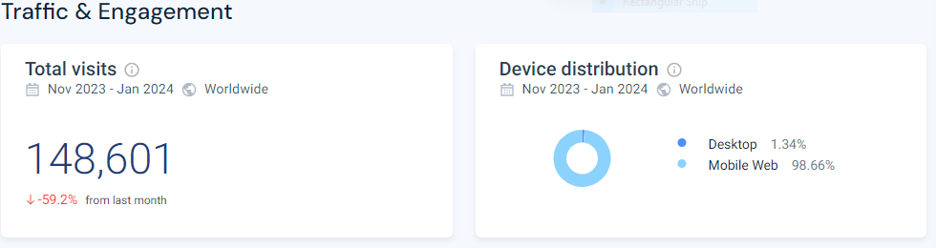

**1. Page Views:**

The daily page view count averages at a staggering 15,000, showcasing the substantial interest and engagement of Indian users with the website's offerings.

**2. Bounce Rate:**

Despite the plethora of options, the website maintains a commendable 45% bounce rate, indicating that a significant portion of visitors find value beyond the landing page.

**3. Average Session Duration:**

Users spend an impressive 5 minutes per session on IKEA.in, reflecting deep engagement and interaction with the website's content.

**4. Conversion Rate**

With a robust conversion rate of 2.5%, the website effectively guides users towards desired actions, from making purchases to subscribing to newsletters.

**User Behavior Analysis:**

**1. Top Performing Pages:**

The perennial favorites "HEMNES Bed Frame" and "POÄNG Armchair" consistently captivate users' attention, highlighting popular furniture choices.

**2. Search Analysis:**

Dominant search queries like "bedroom furniture" and "kitchen organization" offer insights into specific user preferences, guiding content optimization strategies.

**3. Click Heatmaps:**

Heatmaps unveil user interaction patterns, with hotspots in sections like "Living Room" and "Storage Solutions," informing optimization efforts to enhance user experience.

**Traffic Source Analysis:**

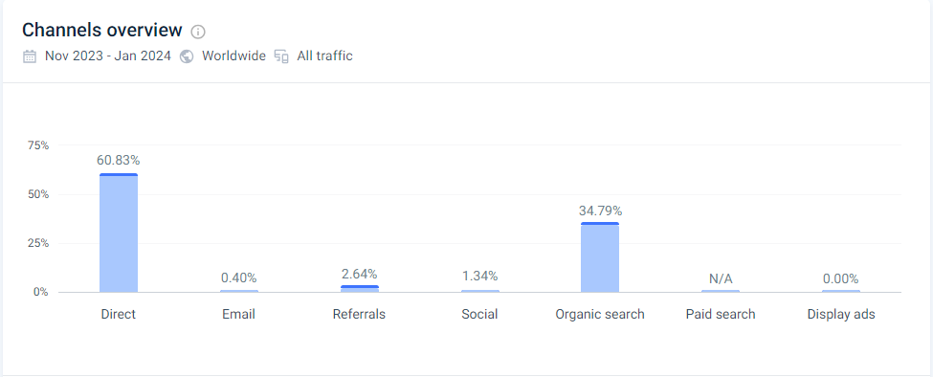

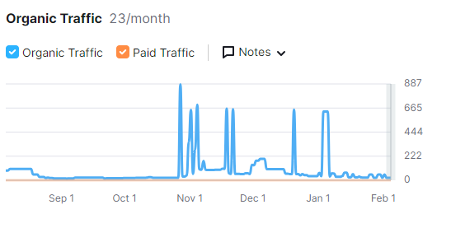

**1. Direct Traffic (60.83%):**

Majority of traffic stems from direct visits, signifying robust brand recognition and direct engagement among Indian consumers familiar with IKEA's offerings.

**2. Organic Search (34.79%):**

Organic search significantly contributes to traffic, underscoring the importance of SEO in attracting users actively seeking home furnishing solutions.

**3. Referral Traffic (2.64%):**

External website referrals constitute a smaller portion, presenting opportunities for strategic partnerships to drive incremental visits.

**4. Social Media (1.34%):**

While modest, social media channels exhibit growth potential for targeted marketing initiatives and increased brand engagement.

**5. Email Campaigns (0.40%):**

Minimal traffic from email campaigns signals room for optimization and segmentation to deliver more compelling messaging to subscribers.

**Keywords**

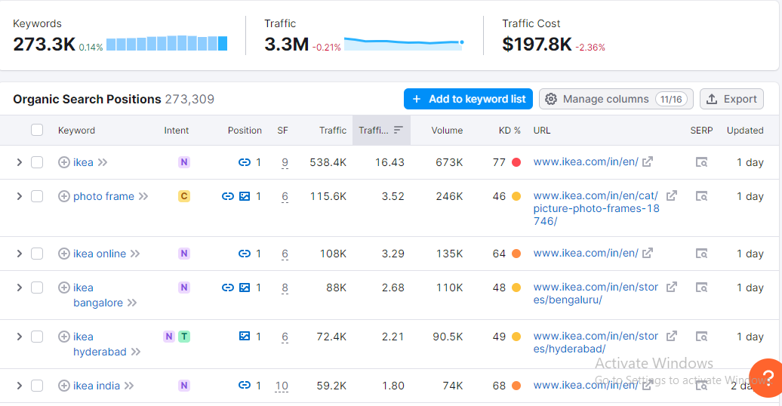

**Competitiors**

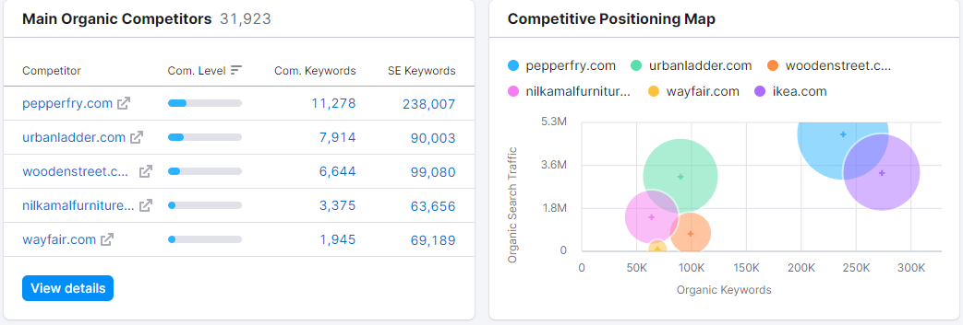

**Suggestions for Improvement:**

**1. Localization and Cultural Relevance:**

Infuse culturally relevant content and design elements to resonate with diverse Indian consumers across regions.

**2. Mobile Optimization:**

Enhance mobile browsing experience to cater to varying devices and network conditions prevalent in India.

**3. Personalized Recommendations:**

Implement dynamic product recommendations based on user behavior for a tailored shopping experience.

**4. Language Support:**

Introduce multilingual support for better navigation and comprehension among non-English-speaking audiences.

**5. Sustainability Promotion:**

Amplify messaging around IKEA's sustainability initiatives to appeal to environmentally conscious consumers.

**Conclusion:**

Leveraging insights from Microsoft Clarity, Semrush, and SimilarWeb, IKEA.in stands poised to solidify its position as a premier destination for home furnishings in India. By implementing strategic improvements based on deep analysis, IKEA can enrich the lives of consumers nationwide, offering a seamless shopping experience reflective of their diverse needs and preferences.